Sterling LaBarbera
14096504

ECE4655 Assignment 2 Report
This lab was about basic image filtering using Mean, Median, and Gaussian filters, and sharpening images with a Laplacian kernel. All methods are similar in execution, setting up the image as an array in Matlab, and using a loop to perform the discrete convolution of the kernel and image. All the filters used were symmetric, and their reversed versions are the same as the original filter.
For the Mean and Median filtering I used the built-in Matlab mean and median functions to generate the appropriate value based on the kernel's location. For the Gaussian filter, I set up the Gaussian kernel manually, using two m*m matrices together to generate the discrete x,y coordinates of each pixel. From there, a final m*m matrix was generated using the Gaussian formula provided in the notes. To make the Gaussian pyramid, I simply added another enclosing loop that down-sampled the filtered image, shrank and recalculated the kernel, and fed the new image back through the filter until the kernel was smaller than 3x3 pixels. Finally, for the sharpening, I hard-coded the two Laplacian filters, passed the test image through, and added the filtered output to the original image. For all the programs, I used 0 padding and added a cleanup loop at the end to remove the added pixels.
The primary issues I ended up having with this lab were with variable type matching. On the initial filtering code, I was able to run without much issue other than one index becoming a signed integer. When I started looping in the pyramid, I had many issues with either indexes going out of bounds, or type errors due to converting between uint8 and double.

Link to Youtube of running the code: https://youtu.be/TRKaOo_IC9A6

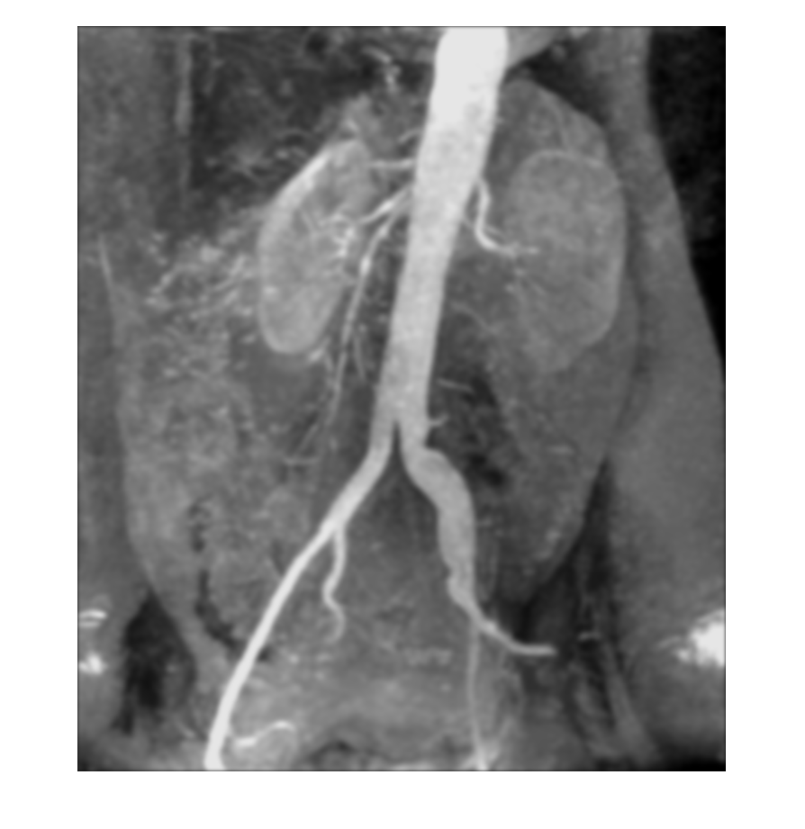
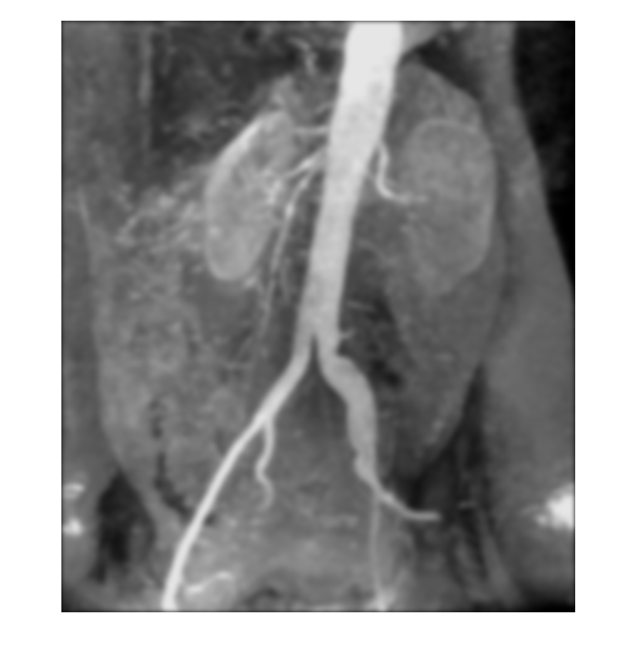
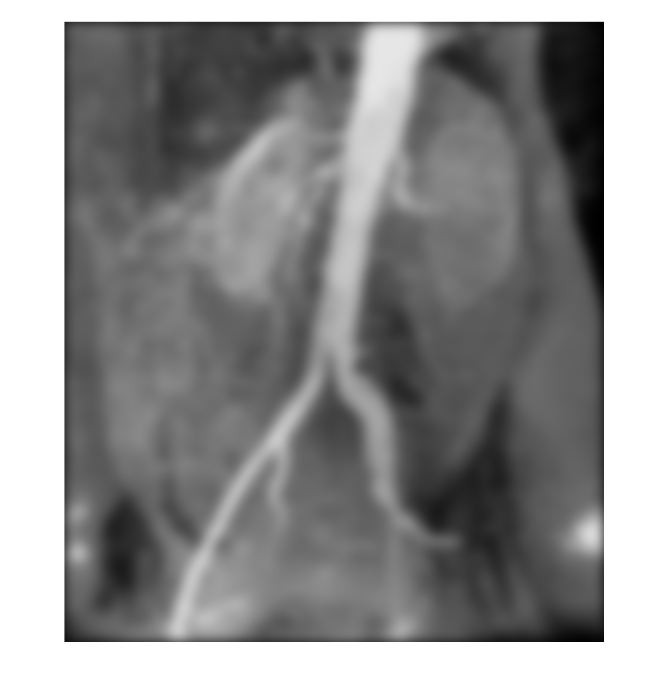
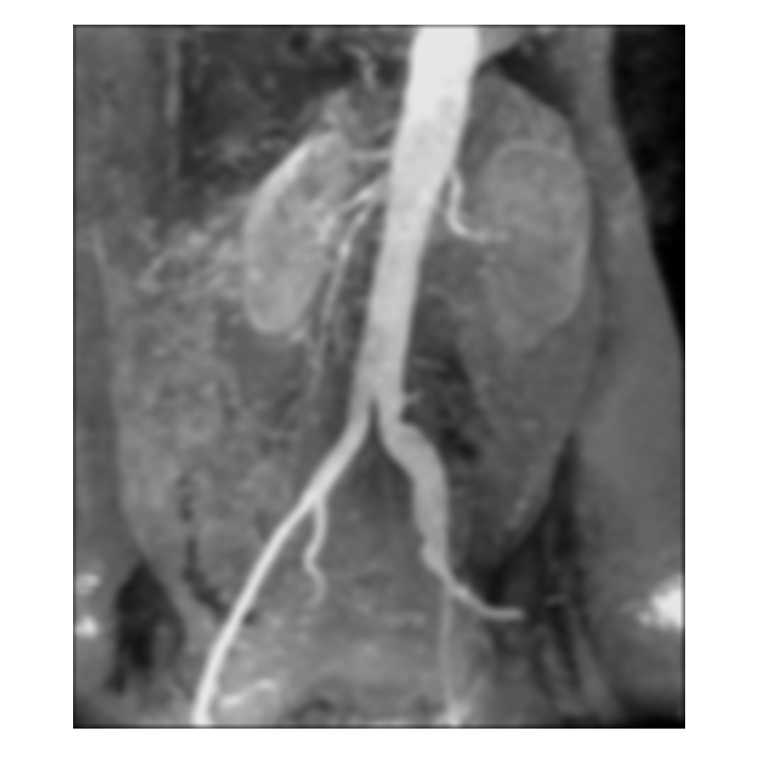
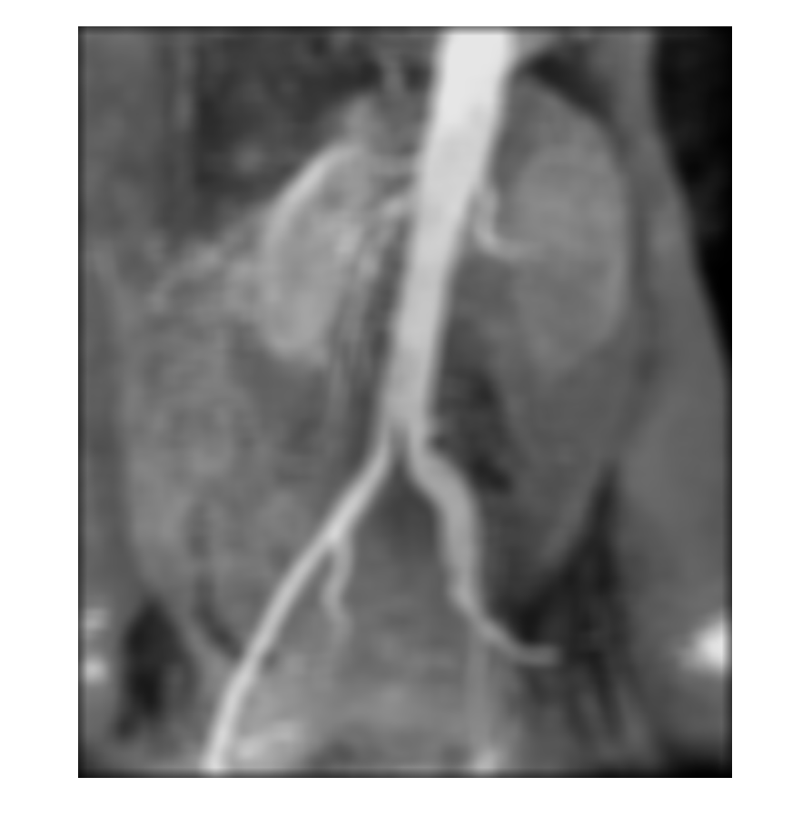
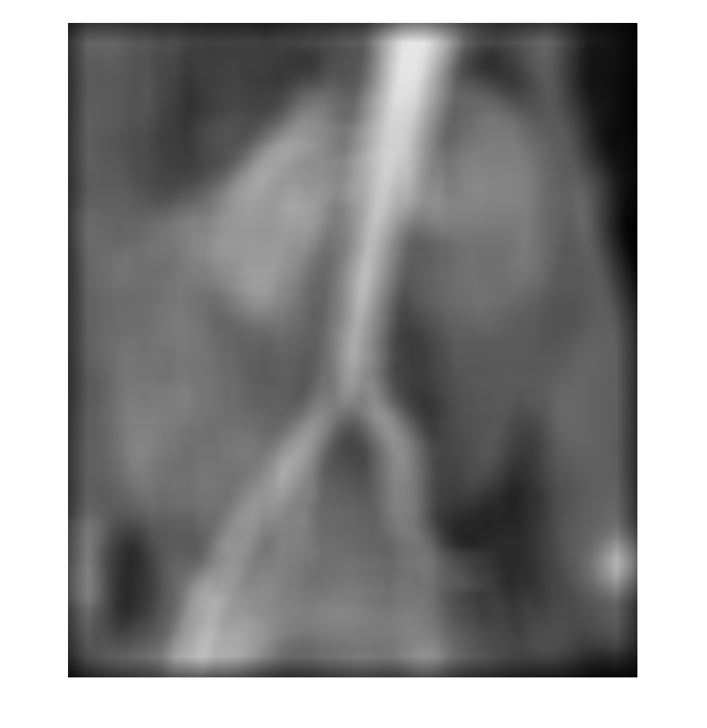

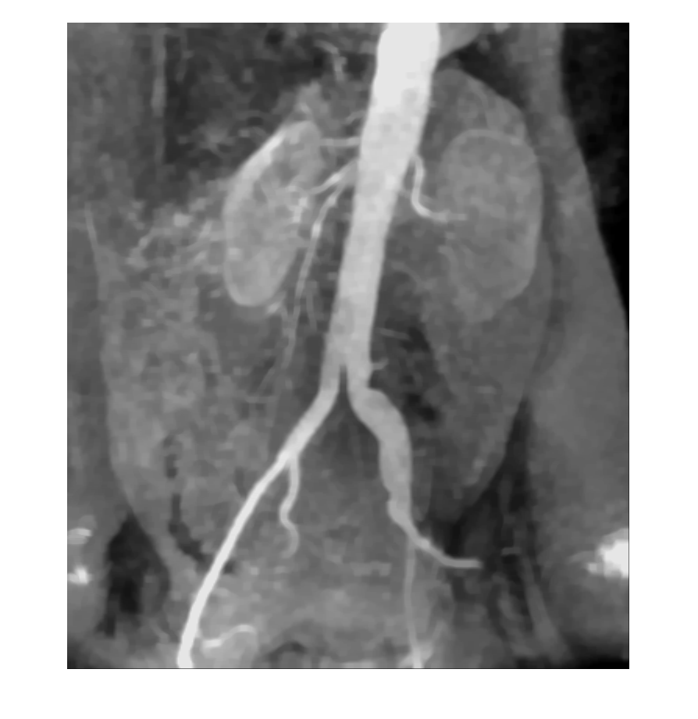
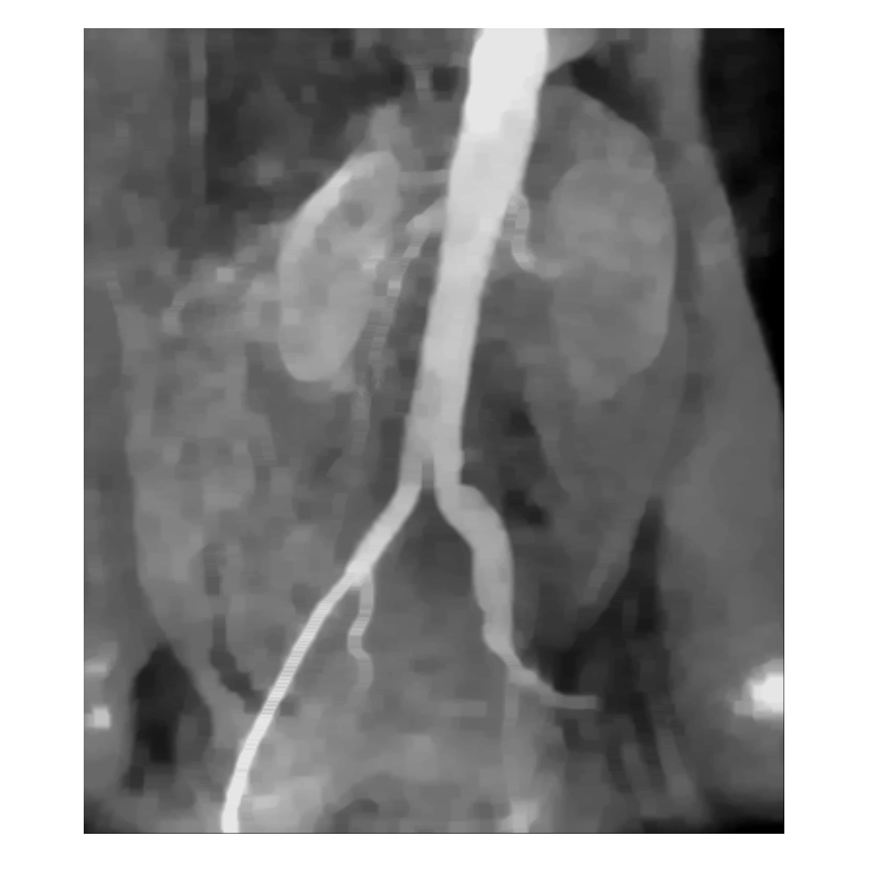
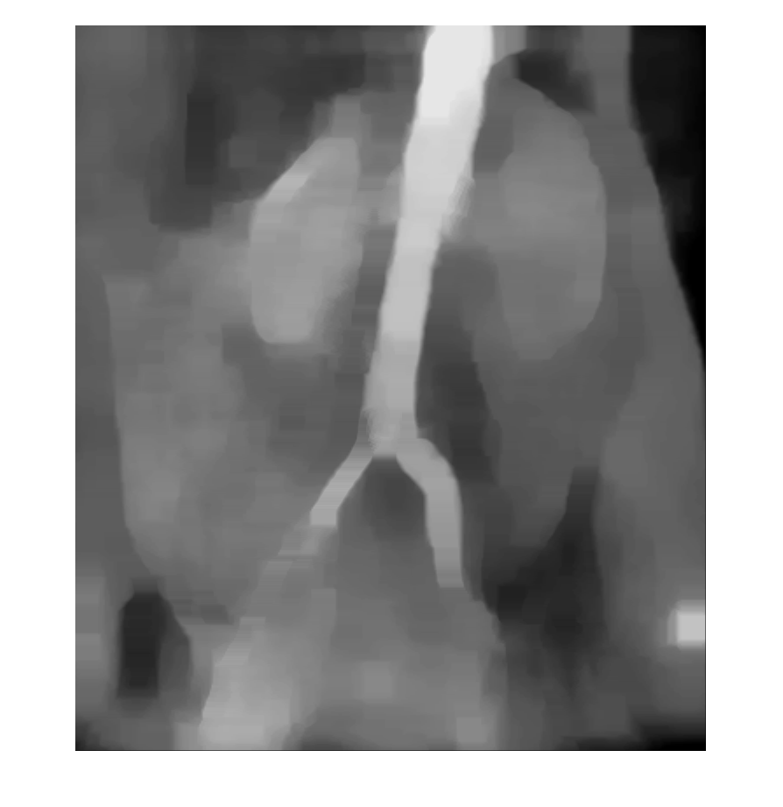
Upper Left: Gaussian filter with kernel size 11x11 Upper Middle: kernel size 21x21
Upper Right: kernel size 51x51
Middle Left: Mean filter, kernel size 11x11 Center: kernel size 21x21 Mid Right: kernel size 51x51
Lower Left: Median filter size 11x11 Lower Middle: kernel size 21x21 Lower Right: kernel size 51x51

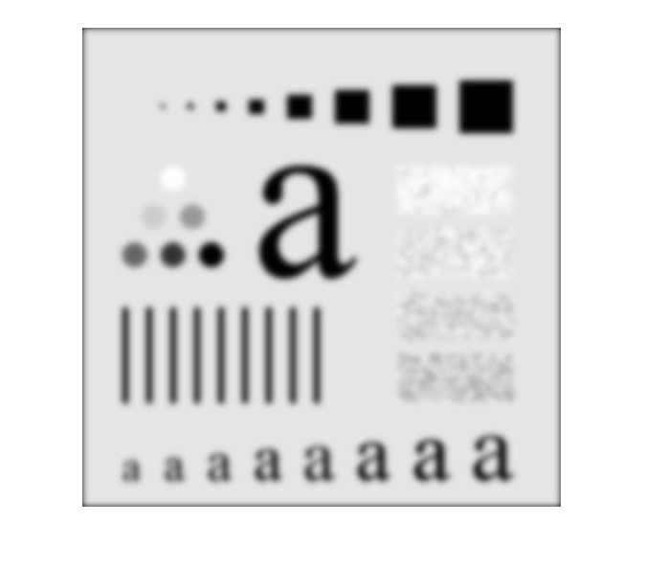
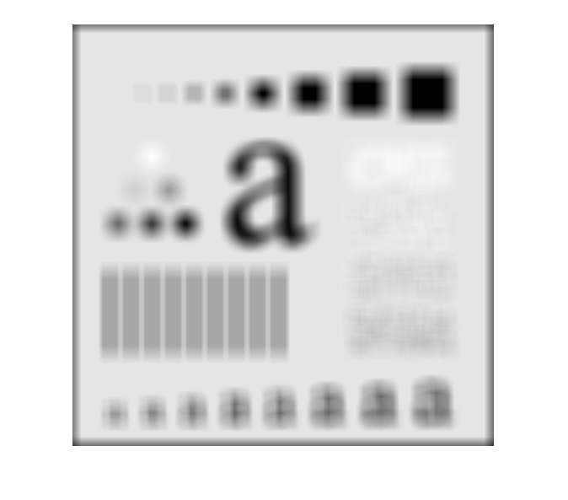
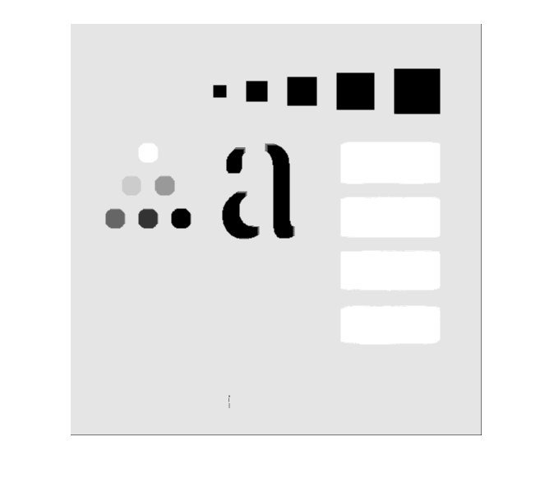
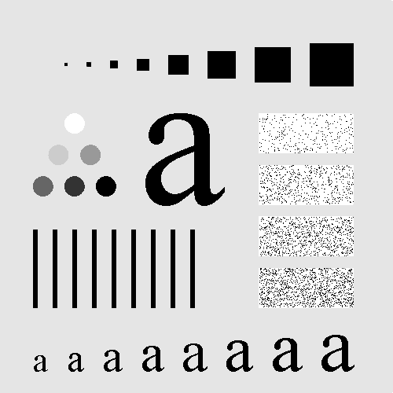
Fig. 0333 Above from left to right: Gaussian, Mean, Median filtering all kernel size 21
Below Right: original

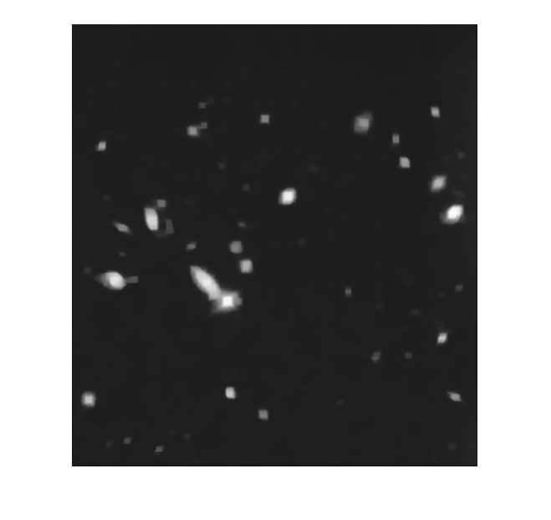
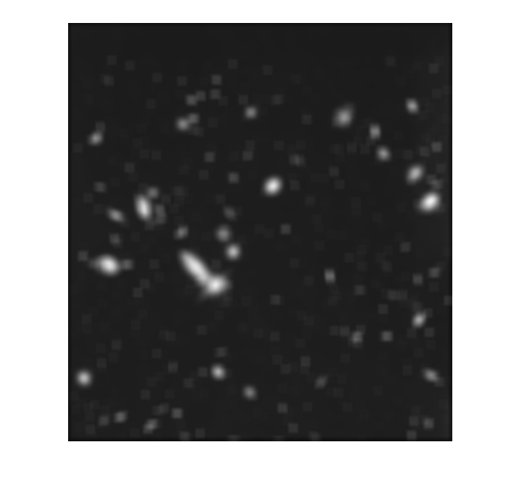
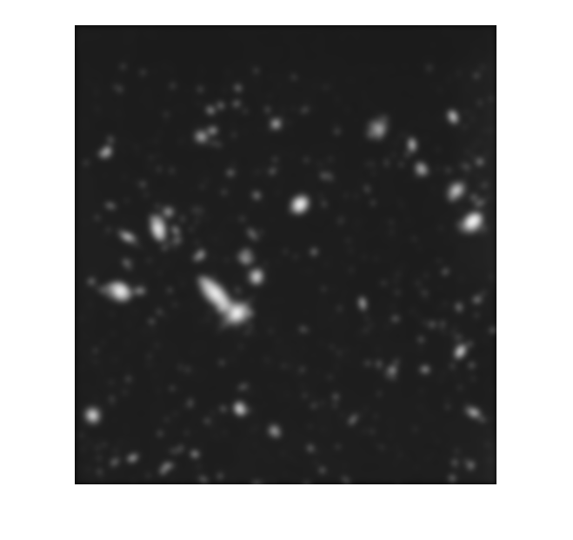
Fig. 0334 from left to right under Gaussian, Mean, Median filtering all kernel size 21

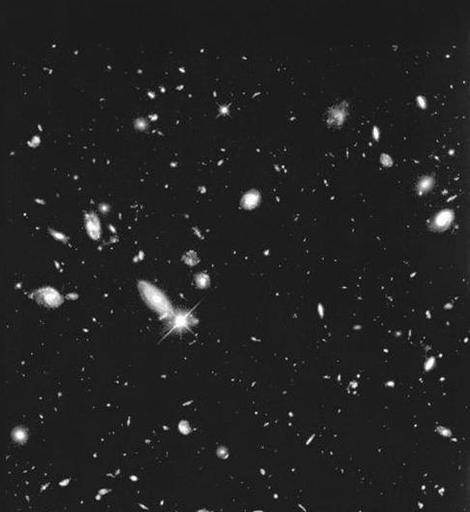
Original

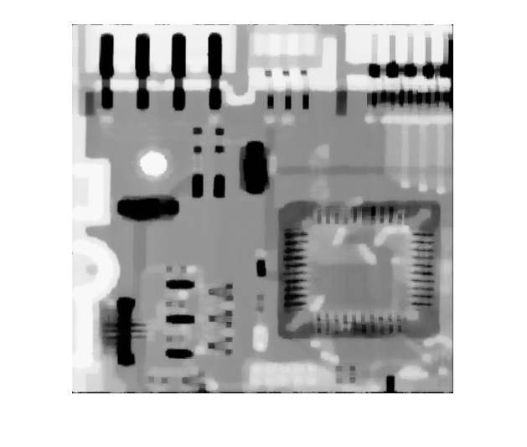
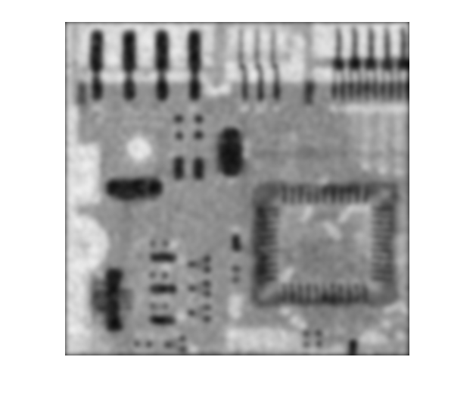
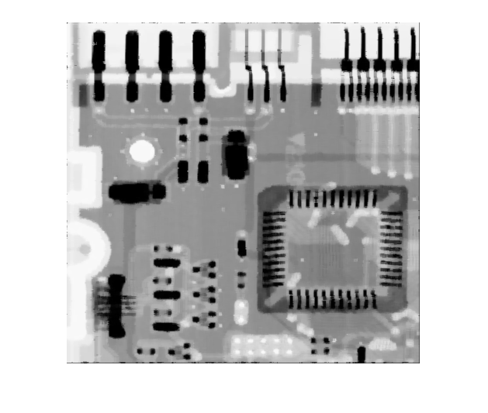
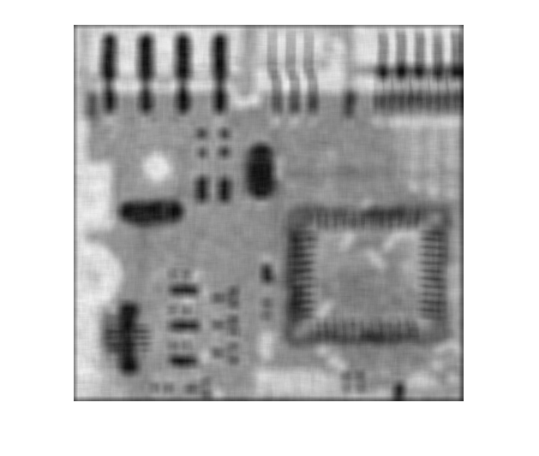
Fig. 0335 Left: Under Mean filter, kernel size 11x11 Middle: Gaussian 21x21
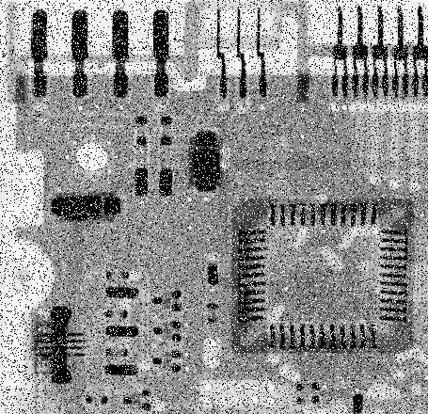
Right: Median size 11x11
Lower Left: Original
Lower Right: Median 5x5

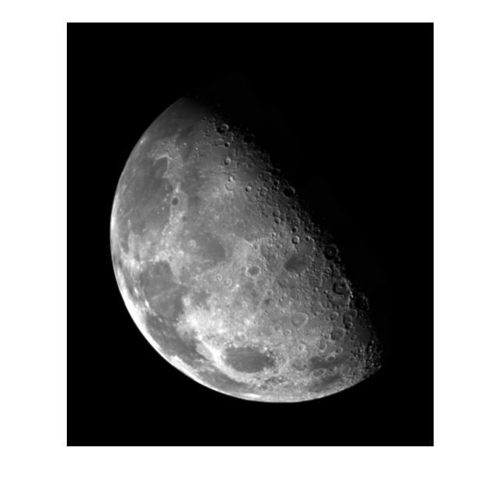
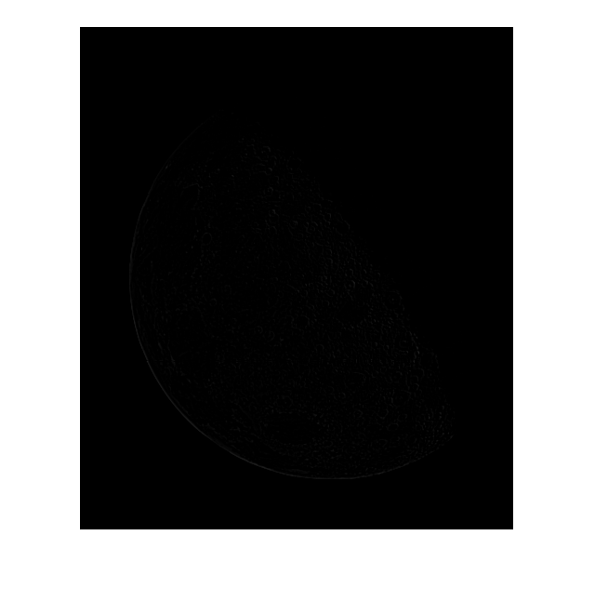
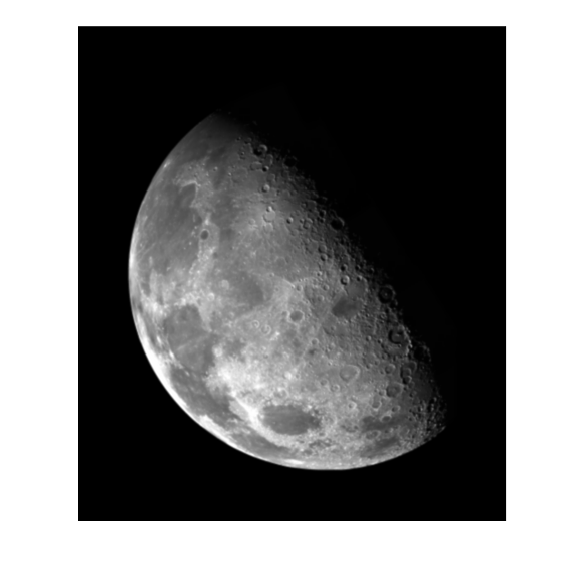
Fig. 0338 Left: after Laplacian mask Middle: original Right: mask + original

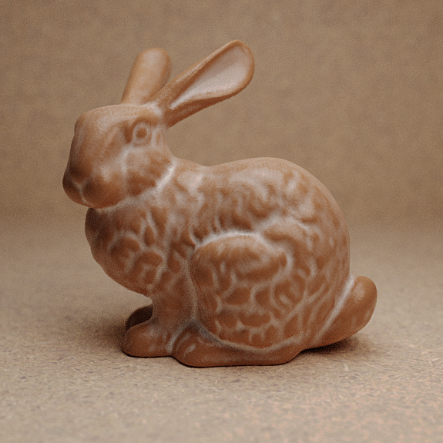
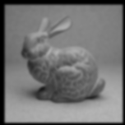
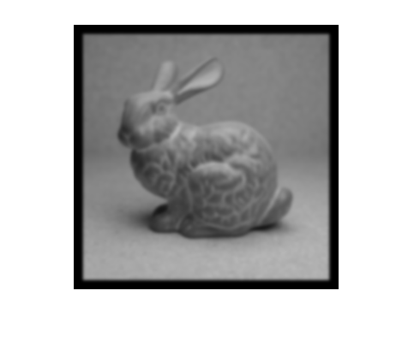
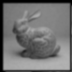
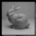
The Stanford Bunny. Top: Original Color
Bottom Row: pyramid of grayscale made by sampling at ½ pixels per row and per column

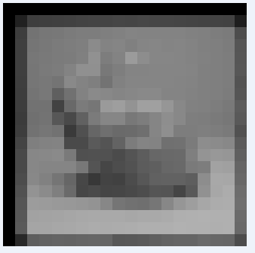
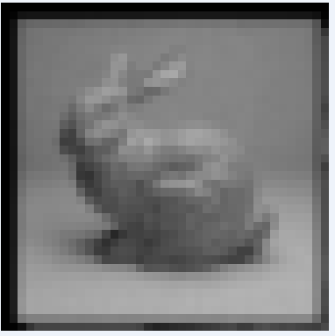
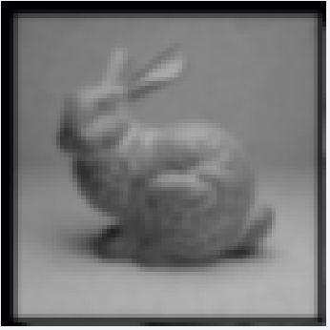

Enlargement of the 3 smallest images of the pyramid to show loss of detail

